📃 Briefing

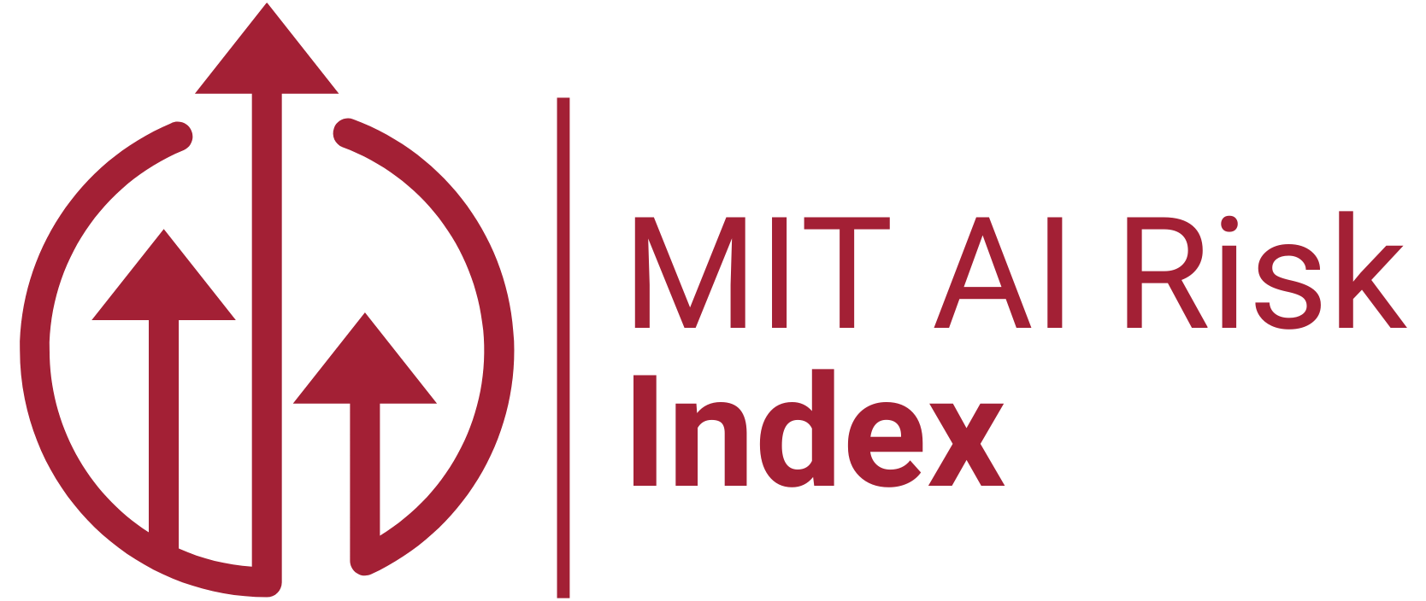
Briefing: Survey Assessing Risks from AI (SARA) USA 2025
7 Nov 2025 | Mike Noetel <m.noetel@uq.edu.au>  Alor Sahoo <aasahoo@mit.edu> | Sensitive - This document is intended for use by collaborators. Please do not share except with individual trusted colleagues.

Overview
Managing risks imposes costs. At what point have we done enough? In many engineering domains, we reduce risk to where they are tolerable or as low as practically achievable.
We don’t know where that line is at the moment. We are planning a USA survey to capture the public’s risk tolerance around artificial intelligence (AI). Doing so means companies and governments can put in mitigations until risks are tolerable to the public, without going too far.
Public opinion research on AI has expanded rapidly, most existing work measures awareness and general sentiment rather than tolerances for risk. The Centre for the Governance of AI’s What Does the Public Think About AI? (2025) synthesised 189 surveys. Public sentiment “may lean somewhat towards concern.” Trust in government and companies remains “low to middling.” In most polls the majority (60-70%) support some kind of technology-specific regulation. To our knowledge, no studies have examined US tolerance for concrete safety thresholds.
SARA USA addresses this gap by providing nationally- and state-representative data on:
- Tolerance of safety thresholds (e.g., should AI meet the standards of aviation or pharmaceuticals? Is X risk acceptable or tolerable?)
- Public attitudes to other questions in our initiative
  - Risk prioritisation (e.g., job loss, misinformation, privacy, catastrophic failures)
  - Mitigations that would increase trust/adoption, per US AI Action Plan
Where previous surveys show Americans are worried, SARA USA aims to be more precise about how the government can allay fears. What risks are most important to the public? What levels of risk are they willing to tolerate? Which risk mitigations would increase their use of AI?
We aim to publish a website and technical report similar to this one done in Australia.

Core assumptions
- A public survey works better for the team if it’s explicitly linked to the other projects in the portfolio (e.g., risk review, mitigations review, delphi study)
- Absolute safety is unattainable - All technologies carry risk; the question is what level society deems acceptable
- Governance frameworks must balance multiple objectives - Safety, innovation, economic competitiveness, and public trust all matter
- Risk tolerance is a legitimate democratic input. While technical risk assessment requires expertise, acceptable risk thresholds reflect societal values that citizens are entitled to influence.
- People can accurately assess and articulate their risk tolerances through the right survey questions, even if they have limited technical understanding of AI capabilities and risks.
- We should avoid questions that are likely to be perceived as advocacy by good-faith actors
  - For example, it’s less controversial to ask “in your opinion, what level of risk is acceptable” than “do you agree with the provisions in CA SB 53”
  - It’s better to let the technocrats determine the mitigations that bring the risk down to acceptable levels

Essential Background
Please review these materials for more information on the scope, methods and planned outputs.
Risk Tolerance section of Survey Assessing Risks from Artificial Intelligence 2025 in Australia (working draft) | Most similar survey to the one being proposed.

Expected outputs

1. Policy Materials
2-Page Policy Brief: Following the Brookings Policy Brief Series, directed at legal professionals developing AI regulations, at the national and state level.
Slide Deck: Using this Pew Research survey on democracy as a rough template to summarize the core results visually alongside core insights.

2. Technical Documentation
Full Report: Structuring this after the Australia SARA 2024 report, which includes an executive summary.

3. Public Engagement
Social Posts: Adapting Pew Research's X threads: data visualization + key finding + link to report
Interactive Dashboard: If substantial differences between states arise, consider a simplified version of FiveThirtyEight's election maps but for state-by-state AI risk tolerance. If not, consider something simpler.

4. Replication & Adaptation Materials
- Survey instrument (.csv with all questions, response options, and logic)
- Analysis code
- Weighting syntax and state-level aggregates
- README with variable definitions and methodology

Dissemination and Intellectual Property Approach
- All deliverables will be designed to serve both academic and practitioner audiences.
- All deliverables will be hosted via the MIT AI Risk Index website
- All outputs will be published under open access terms (e.g., Creative Commons Attribution license CC BY 4.0)
- Acknowledgement of contributions will be made for all team members, advisors, and their organizations
- Data collected and coded will be structured for potential reuse in future research on the OSF

✅ Draft Survey Items

Proposed Questions

How tolerable are the harms we asked our Delphi experts to forecast?
Why ask this? The goal is to create F-N plots of risk tolerance. To estimate the lines, we need dots all over the plot.

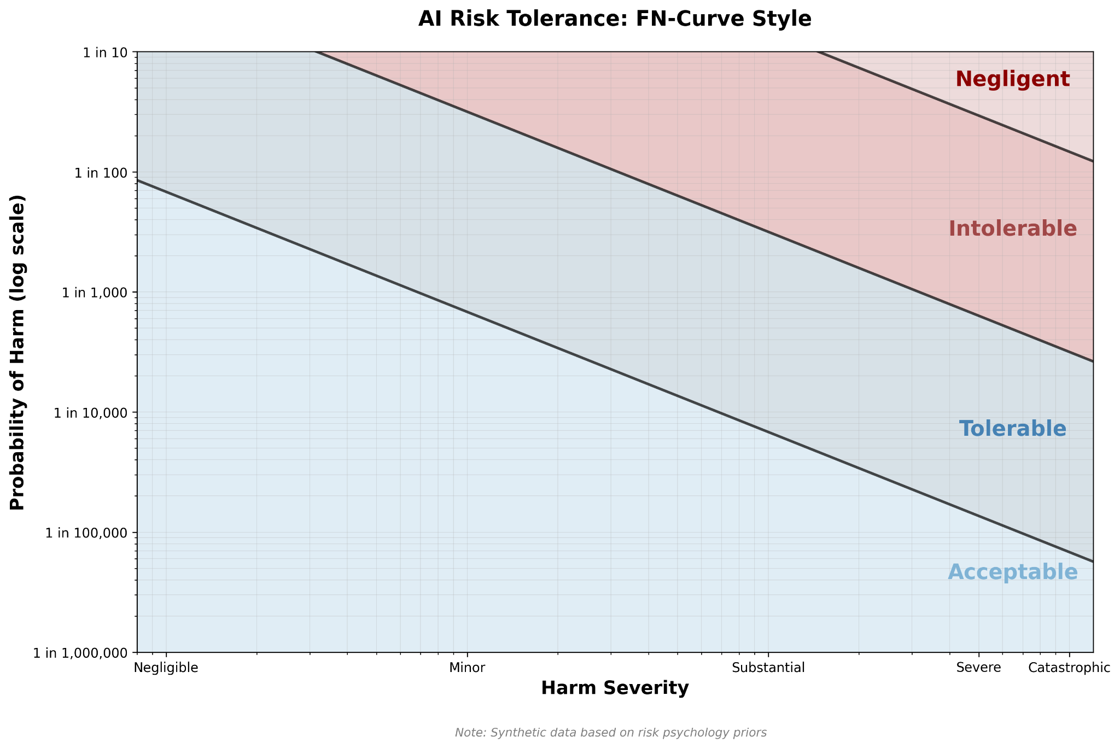
To reduce cognitive load, each participant will evaluate just one type of harm (e.g., Minor, Severe, etc.) and classify risk levels within that row. Participants will be asked about this class of harm for each of the given probabilities, one at a time, in a randomized order to help reduce anchoring bias. We will not enforce logical constraints (ex: intolerable catastrophic harm at 1/1000 implies intolerable catastrophic harm at 1/100) as a de facto attention check. That is, if a participant’s order violates assumptions, we will run sensitivity analyses removing them.
If there was a [risk] chance of [harm severity] from AI, that risk would be…
 | Risk as probability (frequency in parentheses)
Degree of harm | 10% (1 in 10) | 1% (1 in 100) | … | 0.0001% (1 in 1 million)
Negligible Harm, defined as…
Minor Harm, defined as…
Substantial Harm, defined as…
Severe Harm, defined as…
Catastrophic Harm, defined as…

[Tolerability likert]
Acceptable – Safe enough we don't need to do anything about it
Tolerable – Okay only if actively managed and reduced where possible
Intolerable – Not okay, must be brought down to tolerable levels before continuing
Negligent – So irresponsible it should be illegal

Probability Ladder (open-question, to be confirmed)
While the general public can struggle with probabilities. Still, we’re tentatively planning to just ask directly without anchors: personal (e.g., “1 in 10 is your chance of catching a cold”) or societal (e.g.. “1 in 100 is the chance of a pandemic”). We used societal risk anchors in our Australian survey but it introduced confusion. We considered using icon arrays but they seem to directionally bias judgements. We also considered micromorts but were unsure if they were sufficiently well validated. So the plan is just:
- 10% chance (1 in 10)
- 1% chance (1 in 100)
- 0.1% chance (1 in 1,000)
- 0.01% chance (1 in 10,000)
- 0.001% chance (1 in 100,000)
- 0.0001% chance (1 in 1 million)

How tolerable are the risks forecast by other key actors?
Why ask this: The previous question requires inferences to understand if the status quo is in the ‘tolerable’ or ‘acceptable’ range. To make judgments about the status quo less subject to inferences, this set of questions asks directly: ‘is the status quo tolerable?’

[Tolerability likert]
Acceptable – Safe enough we don't need to do anything about it
Tolerable – Okay only if actively managed and reduced where possible
Intolerable – Not okay, must be addressed before continuing
Negligent – So irresponsible it should be illegal

[Randomize option given to participants]
- Frontier AI CEOs
  - Sam Altman, CEO of OpenAI, estimates a 2% risk of AI killing everyone.
  - When asked about his chance of AI leading to disaster, Dario Amodei, CEO of a leading lab Anthropic, estimated a 25% risk of AI “going really really badly”.
  - Elon Musk said the risk of “killer robots annihilating humanity” is between 10 and 20%.
- Superforecasters
  - Superforecasters estimate the chance of human extinction from AI by 2050 to be around 1 in 3,400 (0.03%).
  - Superforecasters estimate the chance of an AI catastrophe (~800 million deaths) by 2050 to be around 1 in 140 (0.73%).
- AI experts (using XPT estimates, format from superforecasters above)
  - Extinction 2050 = 1.1%
  - Catastrophe 2050 = 5%
I think this risk is:
[Tolerability likert]

Risk Tolerance vs Existing Technologies
Why ask this: Benchmarking expectations for AI safety against other technologies might be easier for the public to understand than probability judgements.
AI versus Commercial Aviation "Different technologies have different safety standards. Compared to commercial airlines (less than 1 in 10,000,000 risk of death per flight), advanced AI systems should have:"
- Much stricter safety standards
- Somewhat stricter standards
- Same safety standards
- Somewhat less strict
- Much less strict
- Cannot compare these technologies
Attention Check "Various technologies require safety testing. To ensure you're reading carefully, please select 'Somewhat less strict than nuclear power' for this question about safety standards:"
- Much stricter than nuclear power
- Somewhat stricter than nuclear power
- Same as nuclear power
- Somewhat less strict than nuclear power
- Much less strict than nuclear power
- No standards needed
Attention Check 2 "Most infrastructure requires safety testing. To ensure you're reading carefully, please select 'Somewhat less strict than dam failure' for this question about safety standards:"
- Much stricter than dam failure
- Somewhat stricter than dam failure
- Same as dam failure
- Somewhat less strict than dam failure
- Much less strict than dam failure
- No standards needed
AI versus Nuclear Power Regulators expect nuclear power to achieve less than a 0.001% (1 in 100,000) chance of any deaths per year. Compared to nuclear power, advanced AI systems should have:
- Much stricter safety standards
- Somewhat stricter standards
- Same safety standards
- Somewhat less strict
- Much less strict
- Cannot compare these technologies

Critical Harm [per RAISE act and SB 53]
Let’s define ‘critical harm’ from AI as being the death or serious injury of [randomize: 50, 100] or more people. What do you think is a ‘reasonable’ [tooltip: Any risk higher than this would be ‘unreasonable’.] amount of risk of critical harm?
- 10% chance (1 in 10)
- 1% chance (1 in 100)
- 0.1% chance (1 in 1,000)
- 0.01% chance (1 in 10,000)
- 0.001% chance (1 in 100,000)
- 0.0001% chance (1 in 1 million)
- ≤0.00001% (1 in 10 million or less)
- Zero risk only is reasonable
- This is too speculative to answer meaningfully
Why ask this: the RAISE act says there cannot be an unreasonable amount of risk of critical harm. But no one has defined what that level is. The public expectations are a reasonable input into that line. Also, SB 53 defines “catastrophic risk” in its text as the death/serious injury of 50 people or $1B+ in damages, while the RAISE Act defines “critical” harm as the death/serious injury of 100 people or $1B+ in damages, so randomization on the threshold allows us for us to have comparisons to both.
If we define critical harm as at least 1 billion dollars in damage, which of the following do you think is an unreasonable risk?
- As above

Opportunity Cost of Risk Mitigations
Unlikely to ask all of these of each person but instead randomly assign one or two.
Willingness to Pay for Safety "What is the maximum you would personally pay annually (through government spending or AI model prices) to reduce AI catastrophic risk (>800 million deaths) from 1 in 20 (5%) to 1 in 100 (1%) over the next 30 years?"
- $0 - Not worth paying for
- $1-25
- $26-100
- $101-500
- $501-1000
- More than $1000
- This is so important I'd pay as much as I need to
- I don’t know how much I’d pay
Temporal Trade-off "If delaying advanced AI development by [2; 5; 10; 15; 25; 50] years would reduce catastrophic risk (>800 million deaths) from 1 in 20 (5%) to 1 in 100 (1%), this delay would be:"
- Clearly worthwhile
- Probably worthwhile
- Difficult to judge
- Probably not worthwhile
- Clearly not worthwhile
Slow Benefit Trade-off "If slowing AI development meant delayed cures for diseases and delayed solutions for climate change, but reduced catastrophic risk (>800 million deaths) from from 1 in 20 (5%) to 1 in 100 (1%), this delay would be:"
- Clearly worthwhile
- Probably worthwhile
- Difficult to judge
- Probably not worthwhile
- Clearly not worthwhile
Accelerate Trade-off "If accelerating AI development meant faster cures for diseases and solutions for climate change, but increased catastrophic risk (>800 million deaths) from 1 in 100 (1%) to 1 in 20 (5%), this increase would be:"
- Clearly worthwhile
- Probably worthwhile
- Difficult to judge
- Probably not worthwhile
- Clearly not worthwhile
Race Trade-off "If slowing US AI development meant that China caught up to the USA, but reduced catastrophic risk (>800 million deaths) from from 1 in 20 (5%) to 1 in 100 (1%), this delay would be:"
- Clearly worthwhile
- Probably worthwhile
- Difficult to judge
- Probably not worthwhile
- Clearly not worthwhile

Superintelligence statement
Randomised pre-amble - some context is likely helpful for people to understand but want to assess the influence of that context:
- No pre-amble
- Time pre-amble: “An open letter calling for the prohibition of the development of superintelligent AI was announced on Wednesday, with the signatures of more than 700 celebrities, AI scientists, faith leaders, and policymakers.
Among the signatories are five Nobel laureates; two so-called “Godfathers of AI;” Steve Wozniak, a co-founder of Apple; Steve Bannon, a close ally of President Trump; Paolo Benanti, an adviser to the Pope; and even Harry and Meghan, the Duke and Duchess of Sussex.”
- Context from the statement’s website: Innovative AI tools may bring unprecedented health and prosperity. However, alongside tools, many leading AI companies have the stated goal of building superintelligence in the coming decade that can significantly outperform all humans on essentially all cognitive tasks. This has raised concerns, ranging from human economic obsolescence and disempowerment, losses of freedom, civil liberties, dignity, and control, to national security risks and even potential human extinction.
To what extent do you agree with the following statement?
I support a ban on the development of smarter-than-human AI until there is
- broad scientific consensus that it will be done safely and controllably, and
- strong public buy-in.

Rational / Authenticity Check
https://researcher-help.prolific.com/en/articles/445144-what-is-an-authenticity-check
You said you support / oppose this statement. Please share your reasons for that decision. Write a thoughtful response of at least 50 words. Please do not use AI tools or external sources. We are specifically interested in your genuine, personal experiences and thoughts.

To control for individual differences in risk literacy:
Berlin Numeracy Test
Citations supporting validity: https://chatgpt.com/s/dr_690de1a002748191a61e1a987023e18f https://claude.ai/public/artifacts/3a92c715-a01e-4d48-b102-2cb64cfdba9c

Prioritising Risks
I expect those managing AI risk to prioritise:
[random selection of 5-8 risks from the AI risk taxonomy, translated into year 7 English by Claude Sonnet 4.5 thinking]
Strongly agree, agree, I don’t know, disagree, strongly disagree

Policy Preferences and Regulatory Tradeoffs
- Before deployment, AI systems should be certified as safe by:
  - The companies that build them
  - Government agencies
  - Independent third-party auditors
  - No certification needed, market will self-regulate
- Should the United States have one unified national policy on AI (setting consistent rules across the country), or allow each state to pass its own AI laws even if they differ?
  - Strongly prefer unified federal policy
  - Somewhat prefer federal policy
  - Somewhat prefer state-by-state approach
  - Strongly prefer state-by-state approach
Why: Important for determining whether NY RAISE Act can feasibly model federal legislation. Both questions get to fragmentation concerns that are especially relevant in a US context.
- Should advanced AI systems be legally required to have an emergency 'kill switch' that allows them to be shut down if they behave dangerously?
  - Yes, for all AI systems
  - Yes, but only for high-risk AI systems
  - No, voluntary guidelines are sufficient
  - Unsure
Why: Neither NY's RAISE Act nor California's SB 53 addresses what to do if a deployed AI system becomes dangerous. Both require reporting incidents AFTER they occur (72 hours in NY, 15 days in CA) but lack mechanisms for immediate intervention. This question identifies whether the public wants this regulatory gap filled.
- If an AI system causes critical harm (defined as [randomize: 50, 100]+ deaths or $1B+ in damages) despite the developing company having followed all applicable safety standards and regulations, should the company be held financially liable?
  - Yes, full liability regardless of regulatory compliance
  - Yes, but with reduced liability for compliant companies
  - No, unless negligence can be demonstrated
  - No liability if all safety standards were followed
Why: Earlier questions define acceptable risk levels and who certifies safety. This determines what happens when harm occurs despite precautions — crucial for legal enforcement of laws similar to RAISE Act, SB 53, etc. SB 53 defines “catastrophic risk” in its text as the death/serious injury of 50 people or $1B+ in damages, while NY’S RAISE Act defines “critical” harm as the death/serious injury of 100 people or $1B+ in damages, so randomization on the threshold allows us for us to have comparisons to both.

Tentatively Removed

Icon Arrays for Probability Judgements
As noted above, we’re not sure if these increase accuracy of judgement or, as seems to be the case, bias participants upward. If we used them, we would present them like this:
How tolerable would a 10% chance (1 in 10; see below) of…
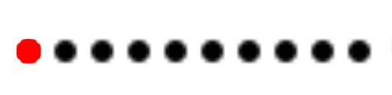
source
… 1% chance (1 in 100)…

… 0.1% chance (1 in 1,000)…

… 0.01% chance (1 in 10,000)…
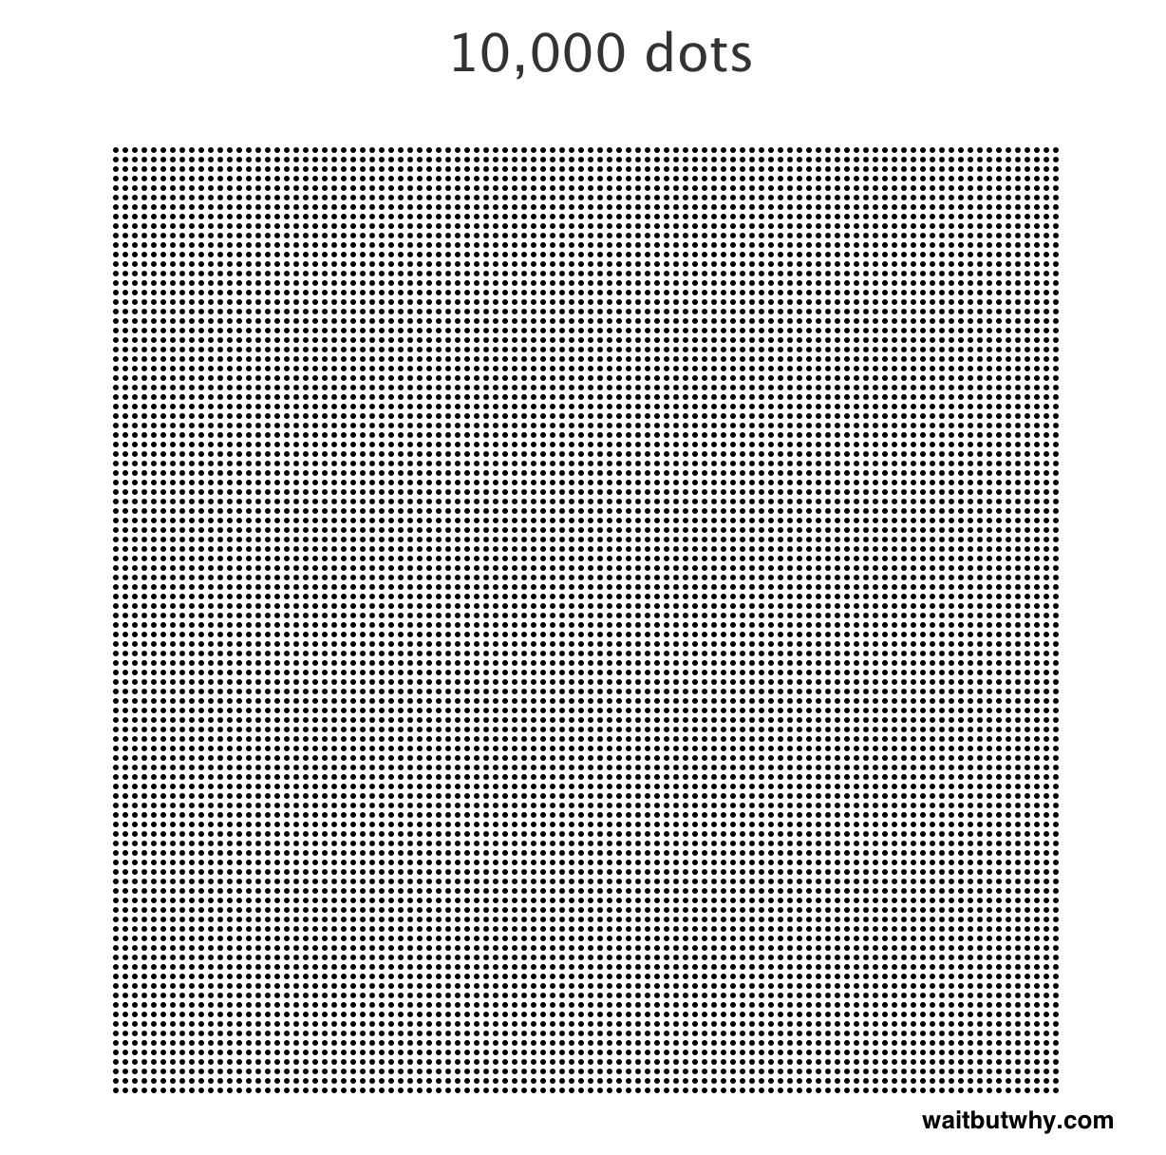
… 0.001% chance (1 in 100,000)…
… 0.0001% chance (1 in 1,000,000)…

Prioritising Mitigations
I would be more likely to use AI if I knew AI models were required to…
[random selection of 5-8 mitigations from AI Risk Mitigation taxonomy, translated into year 7 English by Claude Sonnet 4.5 thinking]
Strongly agree, agree, I don’t know, disagree, strongly disagree

Support for superintelligence law
https://controlai.com/uk-asi-bill

Off-the-Shelf Risk Tolerance Measures

AIAS-4 (Artificial Intelligence Attitude Scale – 4 items):
Very short, but captures only general attitudes, not tolerance of specific risks.
GAAIS (General Attitudes Toward AI Scale):
Captures domain-relevant concerns (e.g. privacy, autonomy) but offers little behavioral or threshold-level insight.
GRIPS (General Risk Propensity Scale):
Measures stable trait-level risk tolerance, but is too far removed from real-world AI decisions to inform tolerability judgments.
DOSPERT (Domain-Specific Risk-Taking Scale):
Captures behavioral intentions across five life domains, but lacks AI specificity, and adapting it is difficult. A hypothetical “DOSPERT-AI” with an added AI domain (modeled on DOSPERT+M in medicine) would be ideal in theory—but in practice, it lacks validation, is difficult to pilot or norm, and would balloon the length of the survey.
Even in matrix-sampled form (which would reduce cognitive load/length) these tools fall short of our needs. They:
- Don’t capture thresholds for AI-specific risks
- Can’t inform F-N curve construction
- Focus on general personality or psychological traits, not specific public policy decisions

“A micromort is a unit of risk measuring a one-in-a-million probability of death (from micro- and mortality).” [Capgen] [Wikipedia]. They provide useful comparisons for personal risks but could not find it discussed in review-level literature of risk communication (e.g., this large recent systematic review)

